**Student Hub - Selling Propositions**

By Kasper L. Jensen

Welcome to Student Hub!

Where you can ask Lisa from RUC what common psychological difficulties adolescent women have, without being creepy. A user-based social network to share thoughts and ideas, but also a helpful tool to fulfill any student needs.

The handy Student Hub app appeals to the average student on a rational and emotional level (USP and ESP appeals). The struggles of a busy student are very relatable, even between different educational institutions. They share the same complications when it comes to practical information and student-related topics. Though this statement also is based upon personal experience, and “the word in the school hallway”, it’s also based on test results from other students.

*“I think the app is very relevant, especially for students with poor economy. It's nice to be aware of the discounts you get. It will be a nice opportunity for students going to museums, library, student cafés more”.*

(Rico Bintzen, 21, Sustainable Fashion Student at KEA)

*“Having a place to share educational information exclusively is awesome, especially if you want to contact strangers. Facebook is too personal for that, I think”.*

(Jonas Herting, 24, Event Manager Student at DMJX)

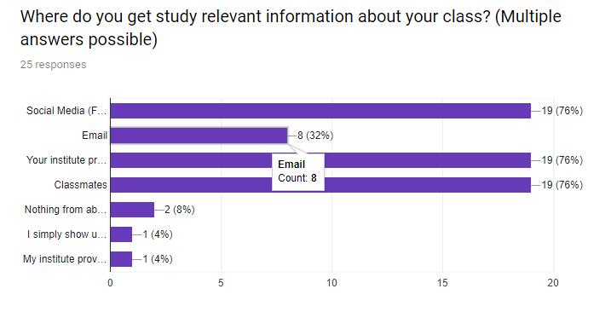

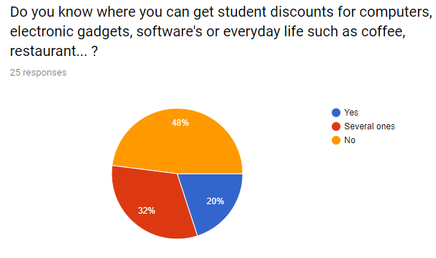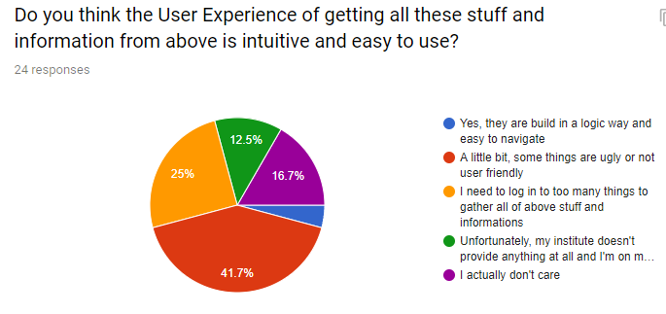

Judging from these survey examples, it becomes very clear that most students don’t have an official and reliable source on where to get useful student-related information. It’s a matter of spreading awareness, but also providing easy accessible information to a student on the go. Furthermore, Student Hub will focus on a neat and simple design, that’s easy to navigate, as since most students agree that the already existing tools are “ugly” and not user friendly. The majority will rely on their classmates, social groups, or social media such as Facebook. However, that’s where the social problem occurs. That’s where Student Hub is the perfect app, for keeping things professional, reliable and relevant.

Communication Plan

**How to reach our users?**

We will make use of several factors, in order to attract our preferred audience. We will appeal to the way they talk, the way connect on social platforms, and the way they wish to help each other and be a part of a community. We especially aim to catch the attention of young students, who most likely aren’t that interested in educational matters in their free time. To do this, we’ll make the app feel as if it’s made by average students, keeping the language unformal and direct. This gives the community feeling of students wanting to help fellow students. This is how we distance ourselves from being the authority that cooperate with universities, and appeal more the students human side.

1. **Purpose**

Student Hub mainly focuses to make student life easier. We want students to have a simple and handy app, which is easy to use, to deliver useful information. Our service will provide users with gathering information, sharing knowledge and being part of a community. Our purpose is to find a user friendly solution to getting exclusive and free information.

1. **Effect**

Using our platform, students are in good relations with their universities. Big companies have the opportunity to source their future, potential employees. Users become more eager to learn. They also have an occasion to develop themselves because of acquiring and sharing the knowledge. Furthermore, the students will be more implored to visit student-friendly facilities, such as museums, events, study cafés etc. if they’re aware they get a discount.

1. **Message**

We aim for students to help each other out, and have them open up their thoughts, struggles, and ideas. An undeniable part of university is the social community, and the strong bond students developed with each other. We want to expand that community and create trustworthy bonds in between other universitites.

1. **Senders**

**Identity:**

We identiy ourselves as a source of free information. A social community, that relies on its users to help one another. The reliability the offered information comes from our source of senders:

* Universities - an institution of higher education where you have access to different research. You can acquire knowledge in many ways – attend to lectures, go to libraries, check on the internet.
* Students – people who want to learn something new, explore world, looking for adventure, sometimes they are shy and they don’t want to share anything with someone, sometimes they are open-minded and they really want to share their experience and socialize
* Teachers – it’s a teacher’s (or professor’s) job to educate, but following a pensum. Individual teachers can share some useful and important notes, regardless of their scheduled lectures.

**Wanted Identity / Image:**

We want our clients to think of us as a reliable and active platform, where they can get answers to any question they’d like. It requires a supportive community, to affect new students to join the community. That’s where we rely on fellow students, teachers and educational institutions to endorse the app. As developers we will also start the first threads in the forum to break the ice. We want our users to feel comfortable with what they share.

1. **Receiver**

The receiver in our case is also the sender – the students. That’s where a special sender / receiver relationship is created. It creates a balanced input/output of information that is shared throughout the community. Having the receivers act as senders, we open up the possibility of growth within the community. Users can carry the acquired information to someone new, who can most likely also teach the sender new in return.

1. **The communication environment**

Student Hub is a platform which takes place online. We are creating only one login for each user. At the beginning, the receiver has access to all “board” which University belongs to. Afterwards, we can divide using the platform in two ways:

- When the Persona is an “active” user who is joining a lot of different “boards”, is open for discussion, sharing information about different topics.

- When the Persona is a “passive” user who is reluctant for any conversation and

1. **Media elements**

* Given that our users are students, we can efficiently advertise our product through social media such as Facebook and Instagram, by proposing our selling propositions. By presenting the struggle of sharing professional information to strangers on Facebook, we can effectively showcase the purpose of the app and attract new users, who can relate to the situation.
* Graphic elements – There is a useful tool for creating a readable and legible platform. Also, graphic elements will improve our navigation system. It became more clear and understandable.
* Pictures – When User add pictures to his profile will be more associated with Student Hub community. Adding pictures can emphasize someone goals and easily draw attention.